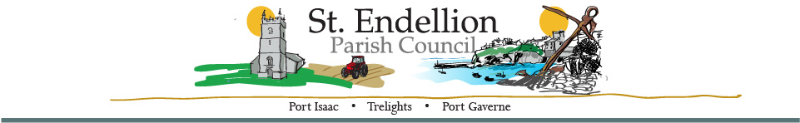
NOTICE AND AGENDA OF THE PARISH ANNUAL MEETING

TO BE HELD AT ST ENDELLION HALL

ON MONDAY 8TH APRIL 2024 AT 7PM
Members of the public who wish to make a representation on any items listed below are asked to contact the Clerk by emailing stendellionpc@gmail.com
by noon Monday 8th April 2024

Minute | AGENDA ITEMS | Action
 | Chairman’s Welcome –
PM01/2024 | Apologies for Absence –
PM02/2024 | Minutes of the 2023 Parish Annual Meeting – 3rd April 2023
PM03/2024 | St Endellion Parish Council – Report by the Chairman. | Cllr. Raynor
PM04/2024 | Members Meeting Attendance – from April 2023 to March 2024
   | Totals
  Cllr Raynor | 11
  Cllr Cleave | 8
  Cllr Williams | 11
  Cllr Webster | 12
  Cllr Collings | 9
  Cllr Button | 7
  Cllr Dawe | 6
  Cllr Hills | 6
  Cllr Symons | 12
  Cllr Pierpoint (Co-opted) | 1
  Cllr Smith (Co-opted) | 3
  Cllr Kirkman (Resigned) | 9
  Cllr Arnold (Non-attendance) | 0
PM05/2024 | NOTES  - Total meetings held 13
PM06/2024 | Meeting Closed –

Signature: ……………………………………………… (D Harrison)
(Clerk) Date: 8th April 2024

